InterestLink Deployment Plan

Overview
This document shows the deployment strategy for InterestLink, which is a social web platform that connects users based on shared hobbies and interests. The system will be deployed using Amazon Web Services (AWS), following a three-tier architecture for improved security, scalability, and performance. This plan ensures that the platform is accessible to users, functional across key features, and prepared for demonstration during the hackathon.

System Overview
InterestLink is a social web application that connects users based on shared hobbies and interests. The MVP supports features such as user registration, interest selection, event discovery, group creation, and community discussions.
Architecture Summary:
- Frontend: Flask (Python) hosted on an EC2 Instance (Public Subnet)
- Backend: Express (Node.js) hosted on an EC2 Instance (Private Subnet)
- Database: MySQL hosted on Amazon RDS (Private DB Subnet)
- Infrastructure: AWS Virtual Private Cloud (VPC) with tiered network isolation.

Deployment Objectives
- Deploy core MVP features on cloud infrastructure
- Ensure communication between frontend, backend, and database layers
- Secure access and data transmission using AWS best practices
- Test the platform end-to-end and validate functionality

AWS Infrastructure Summary
Instances Launched:
Component | Instance Name | AMI | Public IP | Subnet | Status
Frontend | FlaskAppInstance | Amazon Linux 2 | 3.91.179.163 | Public Subnet | Running
Backend | NodeFrontend | Amazon Linux 2 | 52.55.132.109 | Private Subnet | Running
Database | RDS MySQL | AWS RDS Instance | N/A | Private Subnet | Configured separately
Each instance has been launched with appropriate networking and VPC configuration. The backend server and database are protected in private subnets, while the front end is hosted in a public-facing EC2 instance.

EC2 Configuration Details
FlaskAppInstance (FrontEnd)
- Instance ID: i-0052628490c0cb2d9
- AMI: Amazon Linux 2
- Public IPv4: 3.91.179.163
- Instance Type: t2.micro
- Key Pair: HackathonKey
- Security Group: Allows inbound HTTP traffic on port 80
- Role: Hosts the Flask frontend application
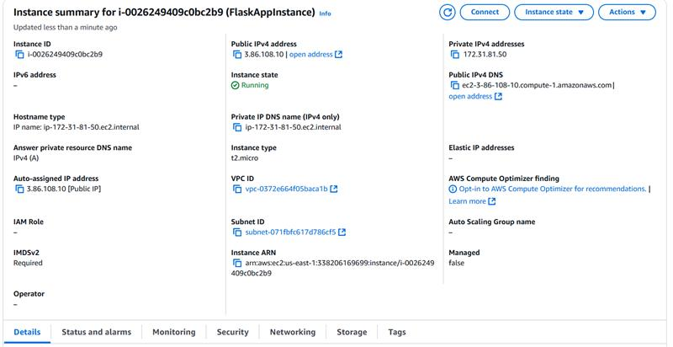

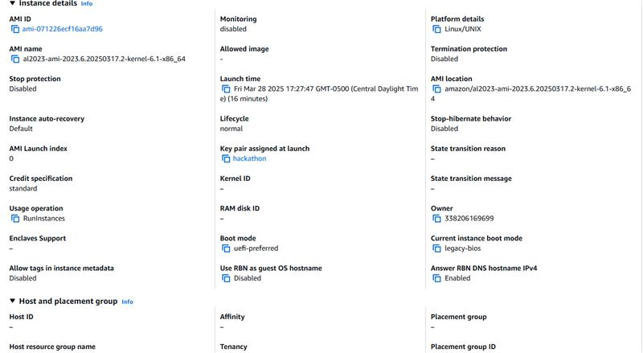

NodeFrontend (Backend)
- •Instance ID: i-05a4ae5d743002234
- AMI: Amazon Linux 2
- Public IPv4: 52.55.132.109
- Instance Type: t2.micro
- Key Pair: HackathonKey
- Security Group: Restricts inbound traffic to frontend instance
- Role: Hosts the Express backend application
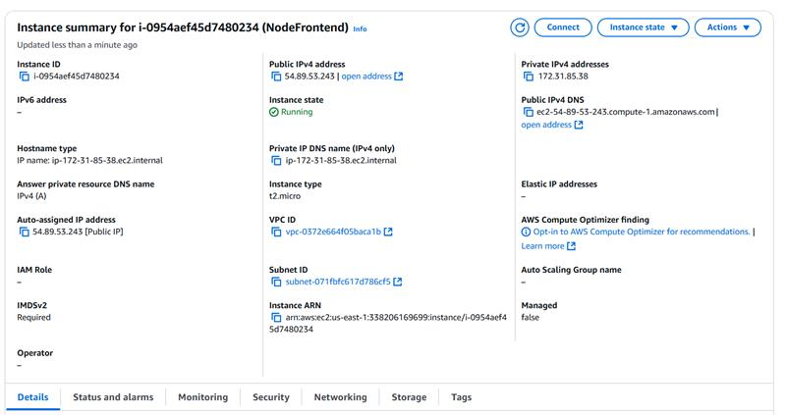

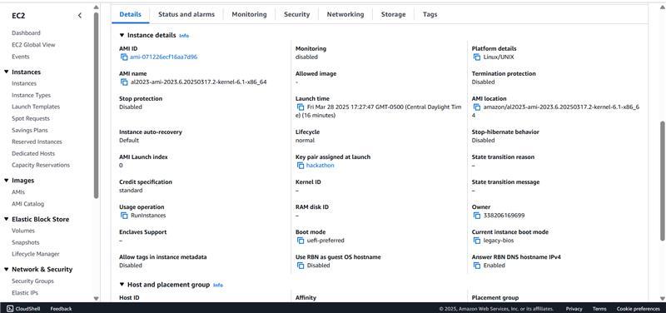

Network and Security Configuration
A custom VPC was used to organize the architecture with:
- A Public Subnet for the frontend
- A Private Subnet for the backend and database
Security Groups:
- Frontend: Allows inbound traffic on port 80 from the internet
- Backend: Allows inbound traffic front frontend only
- RDS: Allows inbound MySQL (port 3306) traffic from backend only

Application Deployment Steps
Frontend (Flask)
1). SSH into Flask EC2 using:
ssh -i HackathonKey.pem ec2-user@3.91.179.163
2). Install dependencies:
sudo yum update -y
sudo yum install python3 git -y
pip3 install flask
git clone <https://github.com/Raycoug22/USITCC-Hackathon-/tree/main/Frontend>
cd frontend
flask run --host=0.0.0.0 --port=80

Backend (Node.js)
1). SSH into Node EC2 using:
ssh -i HackathonKey.pem ec2-user@52.55.132.109
2). Install Node.js
sudo yum update -y
sudo yum install nodejs git -y
git clone <https://github.com/Raycoug22/USITCC-Hackathon-/tree/main/Backend>
cd backend
npm install
node app.js

Database (MySQL – RDS)
Configured in a private subnet with connection string stored in backend .env file
Backend connects using:
mysql.createConnection({
host: "<RDS-endpoint>",
user: "admin",
password: "<password>",
database: "interestlink_db"
});

Conclusion
The InterestLink MVP was successfully deployed to AWS using secure and scalable architecture. All major components — frontend, backend, and database — are operational and integrated. The deployment supports a functional demonstration of all core user features for the hackathon.

